**DAILY ONLINE ACTIVITIES SUMMARY**

|  |  |  |  |  |  |  |  |  |
| --- | --- | --- | --- | --- | --- | --- | --- | --- |
| **Date:** | **26/06/2020** | | | | | **Name:** | **AKASH S** | |
| **Sem & Sec** | **4TH&A** | | | | | **USN:** | **4AL18CS004** | |
| **Online Test Summary** | | | | | | | | |
| **Subject** | | **-----** | | | | | | |
| **Max. Marks** | | **--** | | **Score** | | | **--** | |
| **Certification Course Summary** | | | | | | | | |
| **Course** | **COMPUTER VISION ESSENTIAL** | | | | | | | |
| **Certificate Provider** | | | **GREAT LEARNING** | | **Duration** | | | **5 HOURS** |
| **Coding Challenges** | | | | | | | | |
| **Problem Statement 1:** **Given start and end of a range, write a Python program to print all negative numbers in given range.** | | | | | | | | |
| **Status: executed** | | | | | | | | |
| **Uploaded the report in Github** | | | | | **YES** | | | |
| **If yes Repository name** | | | | | <https://github.com/akashacharya786/lockdown-c-coding>  **https://github.com/akashacharya786/lockdown-java-coding** | | | |
| **Uploaded the report in slack** | | | | | **YES** | | | |

**Online Test Summary:** NOT CONDUCTED.

**Online Certification course:**

Name of the course :computer vision essential

Duration: 5 hours

Certificate provider: great learning

Today I have started a new module that is

* CNN architectures and transfer learning

Snap shot:

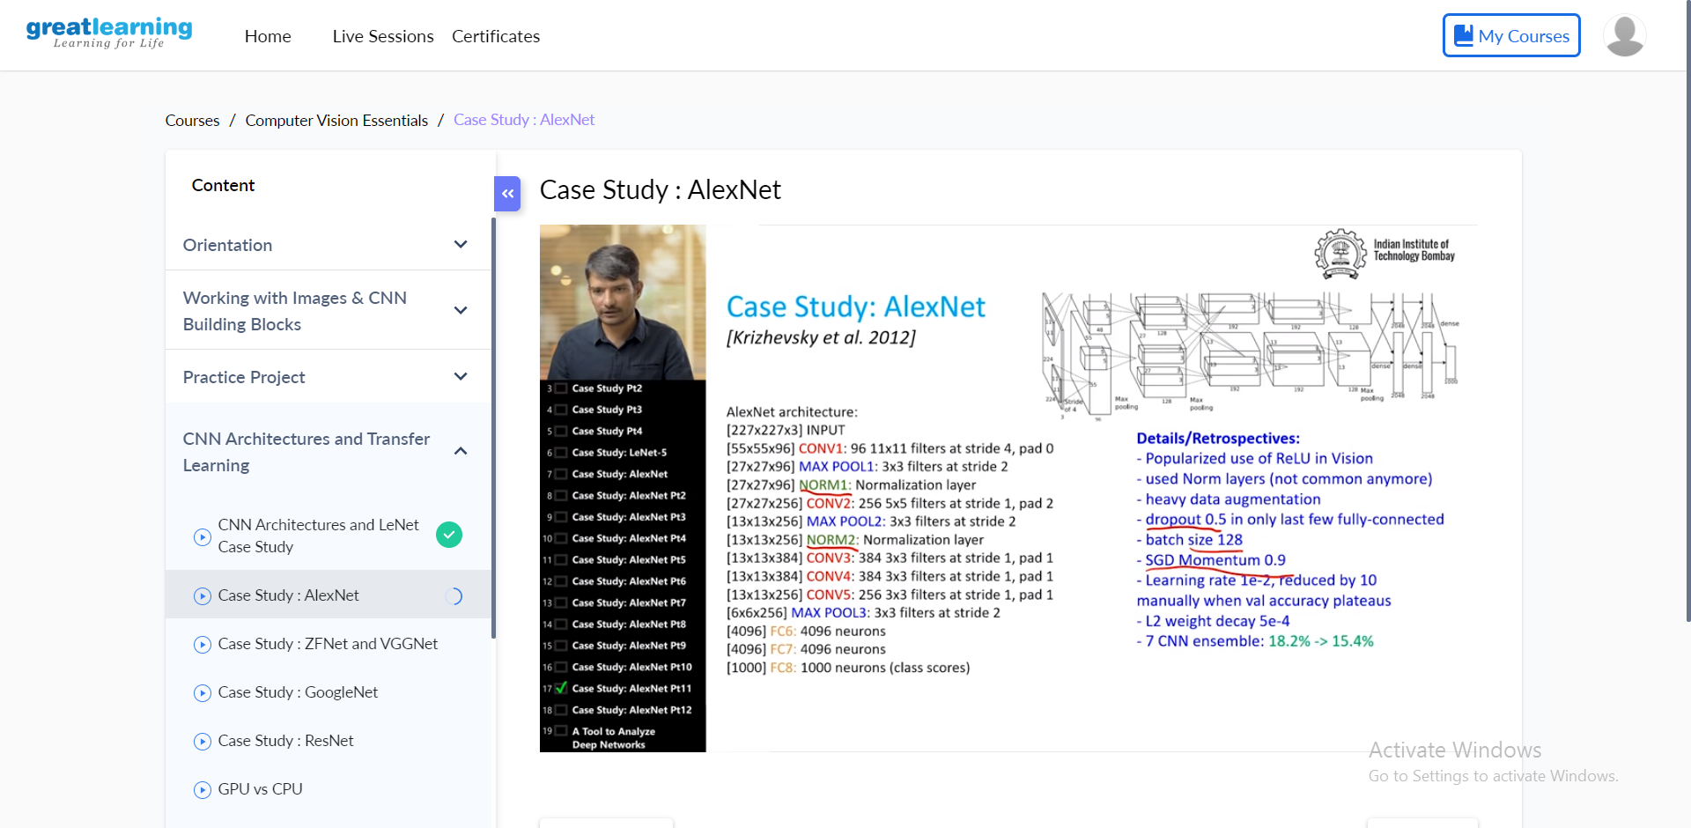

In todays session I learnt case studies.

Online Coding summary:

**1. Given start and end of a range, write a Python program to print all negative numbers in given range.**

**Snap shot:**

